**A Time-Frequency Classifier for Human Gait Recognition**

They use radar to gather data. Movement in arms and legs gives micro Doppler effects. These are shown in the time-frequency domain. They classify gaits using Principle Components Analysis (PCA). The specific gait is defined by various feature vectors. The feature vectors are then used in training a classifier.

Previous articles were more focused on extracting the data rather than classifying the gaits. Time-frequency is used in lieu of STFT because it provides better resolution. Chirplet transform used to model walking gait.

Each gait is defined by its own subspace. For an unknown gait: feature vectors are extracted, then matched to one of the pre-defined gait subspaces. The closes gait subspace will be the likeliest match.

Use the Mahalanobis distance to evaluate how close an unknown gait is to a predefined one. They evaluated three gait types: 1 arm swing, 2 arm swing, no-arm swing.

Issues occur when collecting data from views other than head-on. The body begins to occlude the arms.

Used PCA eigen-decomposition of radar data to define features for 3 gaits and successfully classify unknown gaits.

**Improved Optimization of Time-Frequency-Based Signal Classifiers**

The choice of Time-Frequency Representation (TFR) and the distance measure is critical when we do not know much about the data. They attempt to minimize the classification error. Method is applied to multi-component chirp signals and speech data. Classification performance is substantially improved.

Using a Bayesian (optimal) classifier requires availability of a large learning set of signals. In real life, the learning set is small so suboptimal procedures are used. They minimize the estimated probability of classification error.

To optimize:

1) Choose a distance measure *d*

2) Choose a kernel type φ

3) Determine kernel parameters such that Probability of Classification error (Pc) is minimal for *d* and φ

4) Iterate this procedure for different values of *d* and φ until minimum Pc is found.

Optimization of kernel parameters done using Nelder and Mead direct search algorithm (a.k.a MATLAB *fmins*).

Steps:

1. Compute TFR’s I = 1 ,…,N
2. Compute representative TFR’s
3. Compute distances
4. Compute Pc

Present a TF classification method using only a learning set as the prior information. Has an optimization procedure which minimizes the probability of classification error.

**AUDIO CLASSIFICATION FROM TIME-FREQUENCY TEXTURE**

Compares TF representations of audio signals to texture images. They do audio classification based on treating sound TFR’s as texture images. Find appropriate features for pattern recognition. Audio signals in TFR form present interesting patterns in the visual domain. They use a feature extraction scheme based on TF block matching. This achieves good performance in musical instrument classification.

Algorithm has 3 steps: Transform the signal to TFR. Perform feature extraction by matching TF plane with various pre-learned TF blocks. The minimum matching energy of the blocks makes a feature vector, which is then sent to a classifier.

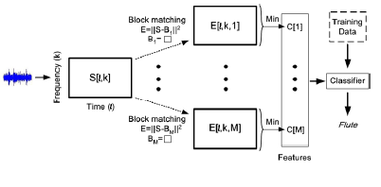

TFR contains complete information of audio signal. The TFR’s also contain distinctive patterns that capture the different characteristics of the audio signals. Different audio types have different vertical and horizontal structures.

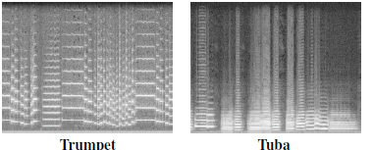

B

Use a simple random sampling strategy to learn blocks. Blocks of various size are applied to capture TF structures. Since audio contains repetitive patterns, random sampling learning is particularly efficient. Patterns that appear with high probability are likely to be learned.

Nearest Neighbor classifier is applied using the minimum block matching energy as features. Other classifiers that might be used are SVM. Average accuracy is 85.5%.